**Learning to read at Alfred Sutton Primary School**

We love reading at Alfred Sutton Primary School. We recognise that reading is the keystone of learning and therefore it is important that every child becomes a confident reader. We teach children to read using the systematic phonics programme Read Write Inc. Phonics.

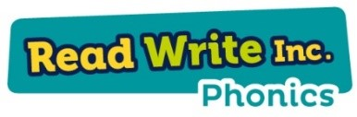**What is Read Write Inc. Phonics?**

Read Write Inc. Phonics (RWI) is a complete phonics programme which helps **all**children learn to read fluently and at speed so they can focus on developing their skills in comprehension, vocabulary and spelling.   RWI was developed by Ruth Miskin.

**How will RWI be taught?**

All children are assessed regularly so they work in a group with children at the same level as them. This allows complete participation in lessons.

***Reading***

The children:

* learn 44 sounds and the corresponding letters/letter groups using simple picture prompts
* learn to read words using Fred talk and sound blending
* read from a range of storybooks and non-fiction books matched to their phonic knowledge
* work well with partners
* develop comprehension skills in stories by answering 'Find It' and 'Prove It' discussion questions

***Talking***

The children work in pairs so that they:

* answer every question
* practise every activity with their partner
* take turns in talking and reading to each other
* develop ambitious vocabulary

***Writing***

The children:

* learn to write and form the letters/letter groups which represent the 44 sounds with the help of fun phrases
* learn to write words by using Fred Fingers
* learn to build sentences by practising sentences out loud before they write them

**Reading**

**Fred Talk**

We use **pure sounds** (‘m’ not’ muh’,’s’ not ‘suh’, etc.) so that your child will be able to blend the sounds into words more easily.  At school we use a puppet called Fred who is an expert at sounding out words! We call it, ‘Fred Talk’. E.g. m-o-p, c-a-t, m-a-n, sh-o-p, b-l-a-ck.

There are three stages of sounds your children learn. They use pictures to help them learn each sound.

* **Set 1 Sounds:** m, a, s, d, t, i, n, p, g, o, c, k, u, b, f, e, l, h, sh, r, j, v, y, w, th, z, ch, qu, x, ng, nk
* **Set 2 Sounds:** ay, ee, igh, ow, oo, *oo,*ar, or, air, ir, ou, oy
* **Set 3 Sounds:** ea, oi, a-e, i-e, o-e, u-e, aw, are, ur, er, ow, ai, oa, ew, ire, ear, ure

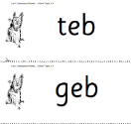**Nonsense words (Alien words)**

As well as learning to read and blend real words children will have plenty of opportunities to apply their sound recognition skills to reading ‘nonsense words’. These words will also feature heavily in the Year One Phonics Screening check in the summer term.

**Storybooks**

When the children are able to blend words together with confidence, they will be introduced to ‘Ditty books’, moving through the storybooks as they learn new sounds.

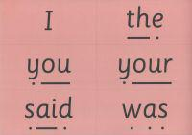Children use sound-blending (Fred Talk) to read short ditties. Within all the books children will have **red** and **green** words to learn to help them to become speedy readers.

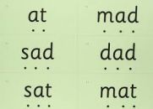**Red** words are words that are not easily decodable and are challenge words to extend children’s vocabulary. **Green**words are linked to the sounds they have been learning and are easily decodable.

During the RWI sessions children will read the books three times and at each new reading they will have plenty of opportunities to practise using their developing comprehension skills.

**Talking**

In any lesson it is important that all children are fully involved in the learning activities if they are to make the best progress. During phonics all children are expected to contribute to lessons.

**Talking Partners**

Children are paired with a ‘talking partner’ who they sit with on the carpet and at tables. Throughout the lesson children are asked to ‘talk to their partner’ to come up with a shared response. This means that all children get the opportunity to think, discuss and express themselves orally. The teacher then collects feedback from the different partners. This goes along with a no-hands-up policy.

Working with a talking partner means that:

* some children feel more confident discussing and coming up with a shared answer
* over time, children begin to give more detailed answers
* children gradually develop higher-quality talk.

**Writing including spelling**

Children are asked to spell simple words as soon as they know the first 5 single sounds, moving towards whole sentences when more sounds are known.

**Fred Fingers**

We teach children to spelling using Fred Fingers. Every day the children are asked to spell the words they are reading during their Speed Sound lesson. It is a tool they can use so they will be able to spell any word.

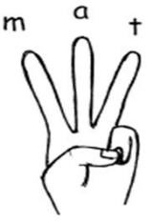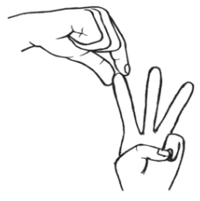The children:

* say the word they want to spell
* count the number of sounds in the word
* pinch the sounds onto their fingers
* write the corresponding letter

**Hold a sentence**

As they move onto ‘Ditties’ and Storybooks the children are challenged to use their developing phonic knowledge to write short sentences.

The teacher tells the children the sentence they are going to write. They then practice it all together until they can remember the sentence. Before the children write it down, the teacher shows them how, referring to all the skills they will need to use to be successful.

**Useful links:**

* Ruth Miskin Training <https://www.ruthmiskin.com/en/find-out-more/parents/>
* Ruth Miskin Facebook page <http://www.facebook.com/miskin.education>
* Ruth Miskin Twitter page <http://www.twitter.com/RuthMiskinEdu>
* Ruth Miskin YouTube channel <https://www.youtube.com/channel/UCo7fbLgY2oA_cFCIg9GdxtQ>
* Parent video: How to say the sounds <https://www.youtube.com/watch?v=TkXcabDUg7Q>