**Now/ Next boards**

A Now and Next board is a visual support tool to help children understand and anticipate what is happening in their daily routine by providing a clear and structured representation of current and upcoming activities. The board typically consists of two sections: "Now" and "Next."

The "Now" section shows the current activity or task your child is engaged in. This helps your child stay focused on the present and understand what is expected of them.

The "Next" section shows the upcoming activity or task in your child's routine. This helps them prepare for the transition to the next activity, reducing anxiety and promoting a smoother transition between tasks.

The Now and Next board is often created with visual cues, such as pictures or symbols and provides a tangible and concrete way for children to understand and anticipate the sequence of events in their daily schedule. At Alfred Sutton Primary School, we use Widgit symbols on our Now/ Next boards.

It serves as a supportive tool to enhance communication, reduce anxiety related to transitions, and promote a sense of predictability and routine for your child.

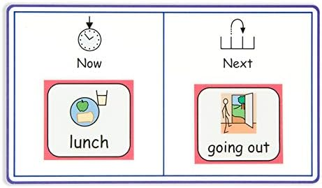

**Here are a few practical ideas to use a Now and Next board at home**:

* List the tasks or activities. These can include chores, homework, playtime, meals, bedtime routines, etc.
* Determine the order of tasks. The "Now" section should contain the current or ongoing task, while the "Next" section should list the upcoming task.
* If your child is younger or responds better to visual clues, use pictures or symbols to represent the tasks. This can make the board more engaging and accessible.
* As your child completes the tasks, move them from the "Next" section to the "Now".  
  It’s important to be flexible with the board. It's a tool to help, not a strict schedule. If priorities change, update the board accordingly.  
  The Now and Next board is a great way to celebrate accomplishments. Acknowledge and praise your child for completing tasks.
* Involving your child in updating the board will empower them and promote ownership.

Video Example: YouTube- Now and next boards (Dorset HealthCare University NHS Foundation Trust)