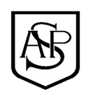
Alfred Sutton Reading Spine – ARP – Autumn:
Year A Core Texts |  | Year B Core Texts
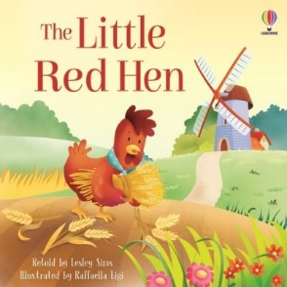  The Little Red Hen by Lesley Sims and Raffaella Ligi | 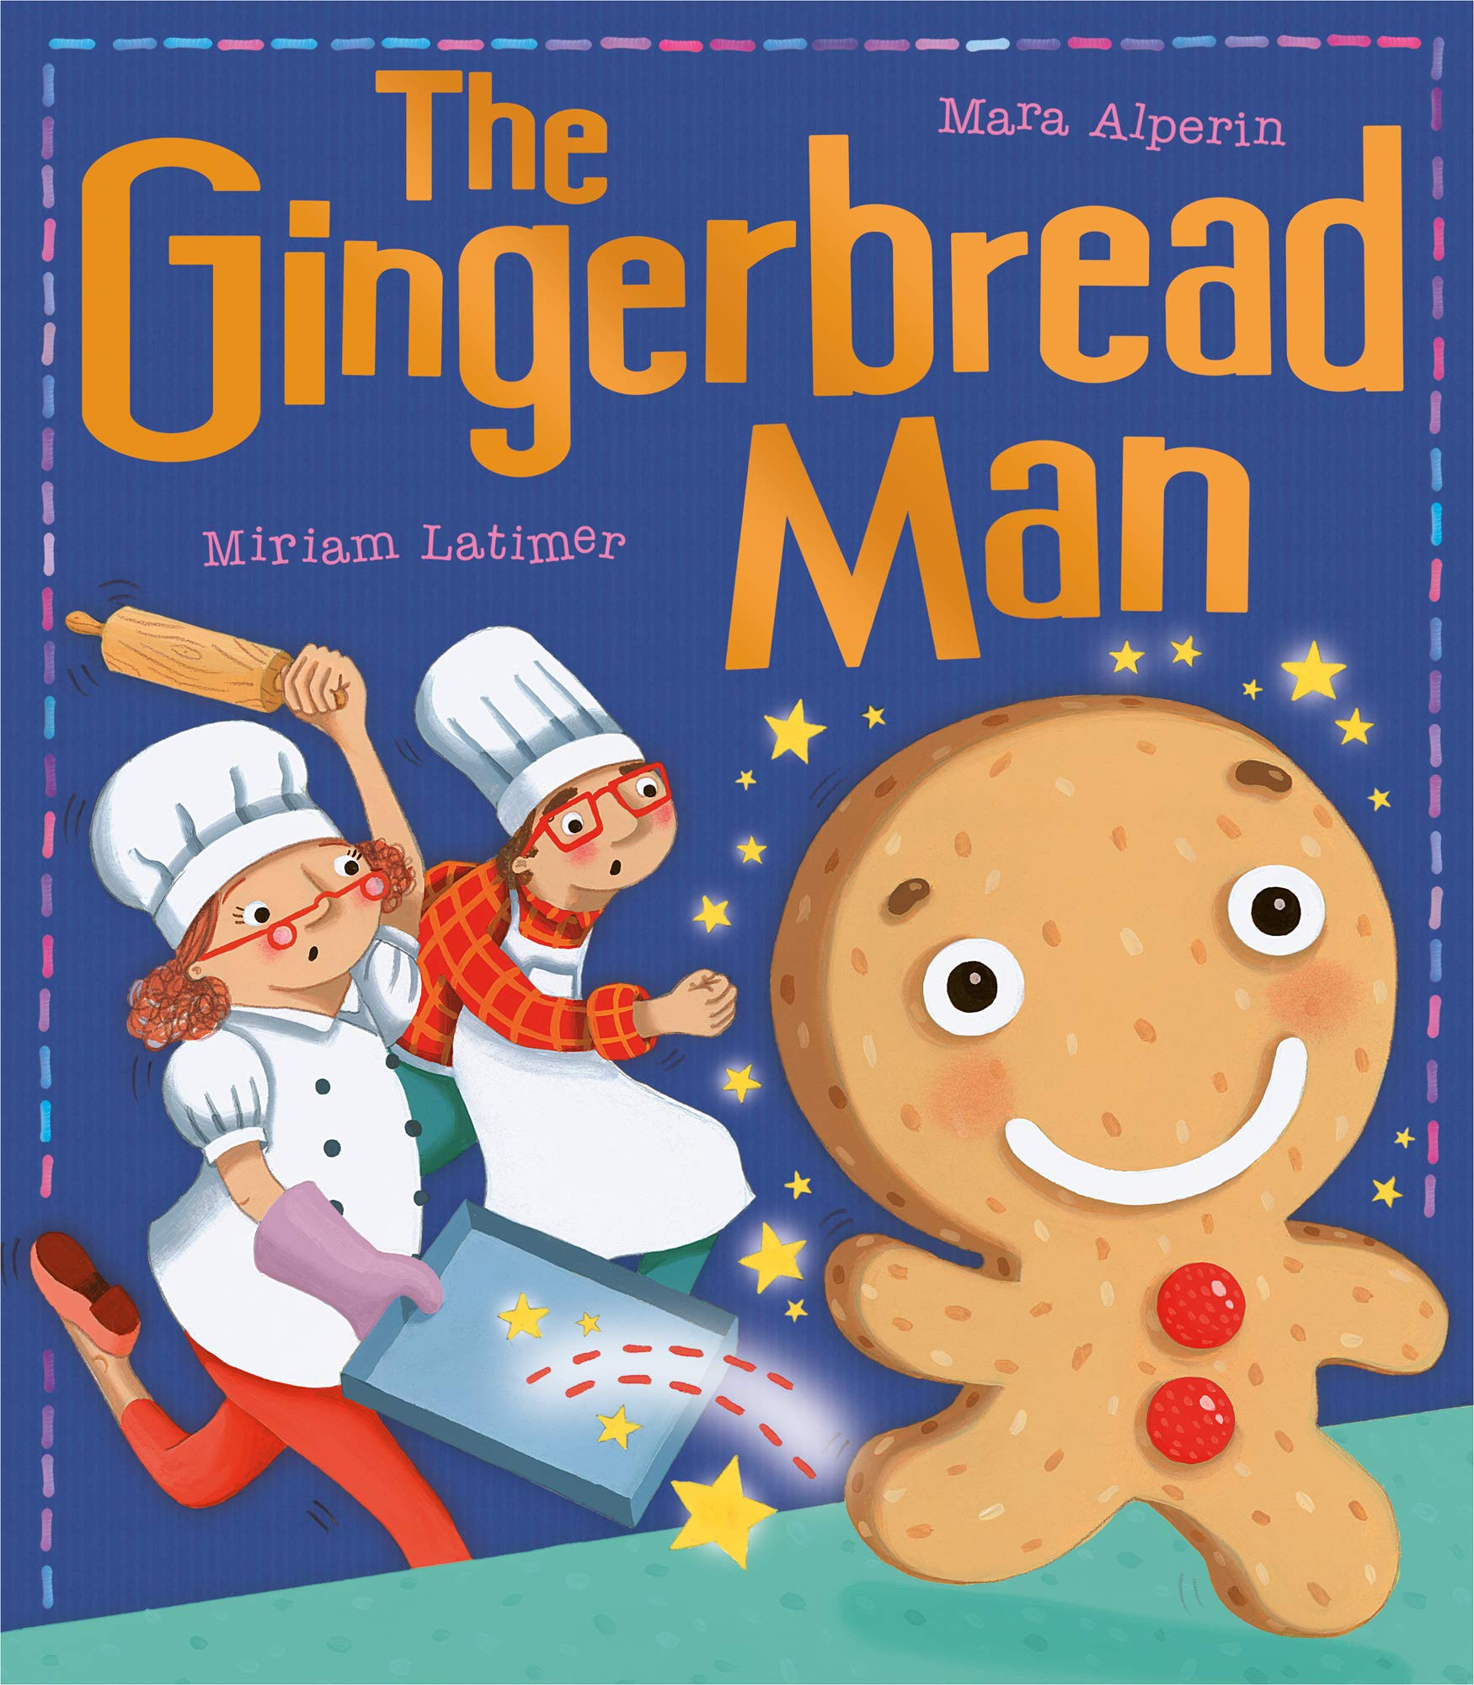  The Gingerbread Man by Mara Alperin and Miriam Latimer | 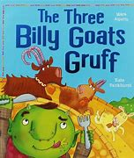  The Three Billy Goats Gruff | 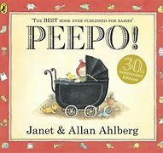  Peepo by Janet and Allan Ahlberg
Complimentary Texts Year A |  | Complimentary Texts Year B
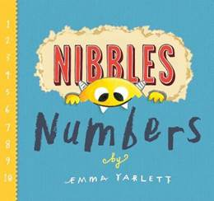  Nibbles Numbers by Emmac Yarlet | 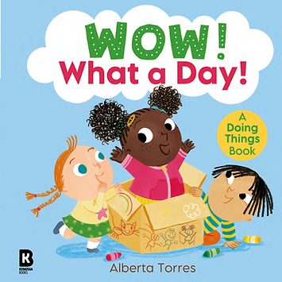  Wow! What a Day by Alberta Torres | 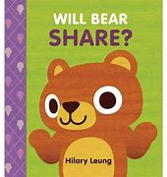  Will Bear Share by Hillary Leung | 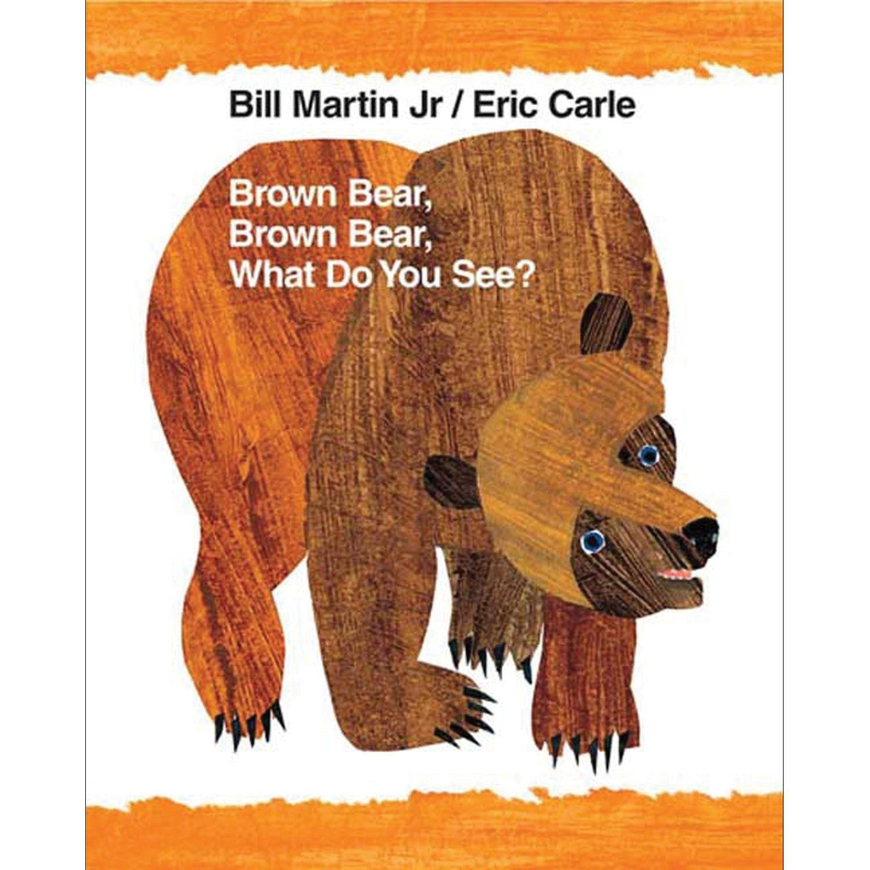  Brown Bear, Brown bear what do you see? by Bill Martin Jr and Eric Carle
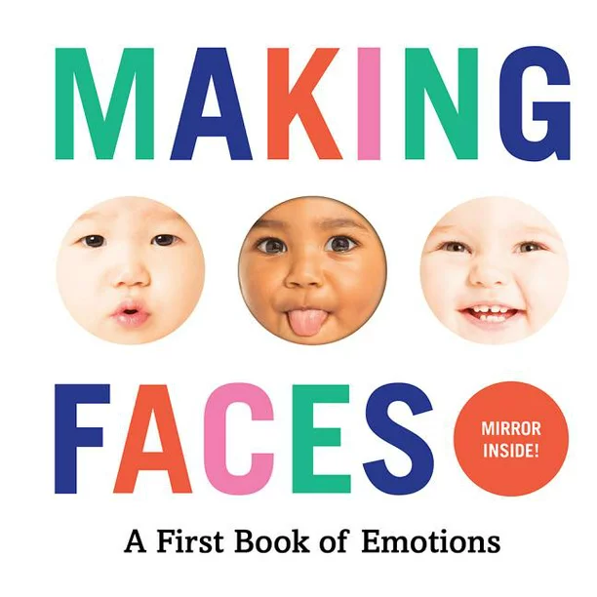  Making faces: A first book of emotions | 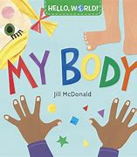  My Body by Jill Mcdonald | 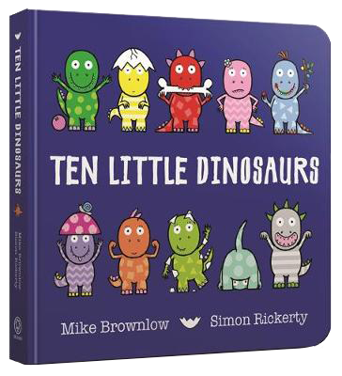  Ten Little Dinosaurs by Mike Brownlow | 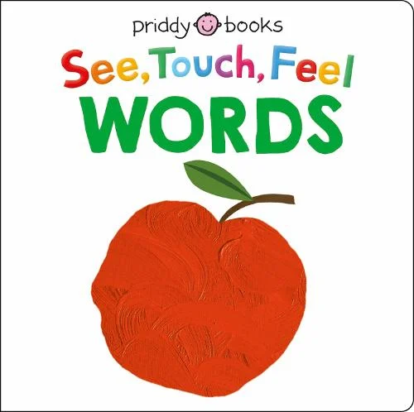  See touch feel words by Roger Priddy
Alfred Sutton Reading Spine – ARP – Spring:
Year A Core Texts |  | Year B Core Texts
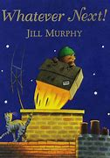  Whatever Next by Jill Murphy | 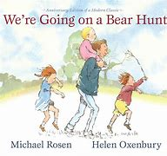  We’re Going on a Bear Hunt by Micheal Rosen | 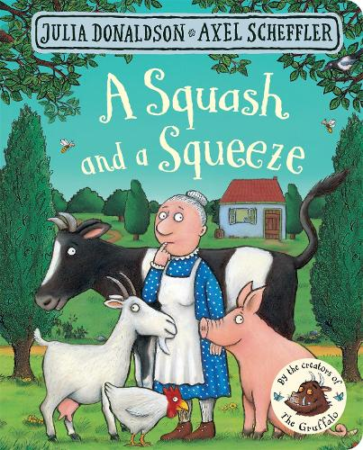  A Squash and a Squeeze by Julia Donaldson | 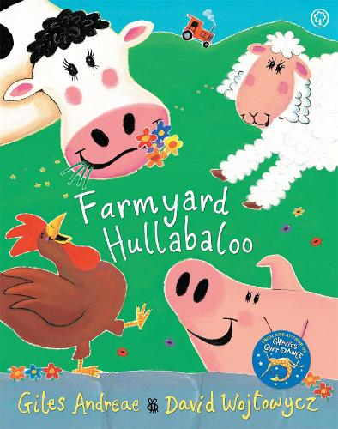  Farmyard Hullabaloo by Giles Andreae
Complimentary Texts Year A |  | Complimentary Texts Year B
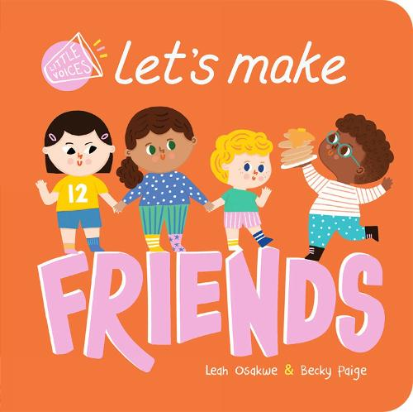  Lets make Friends by Leah Osakwe | 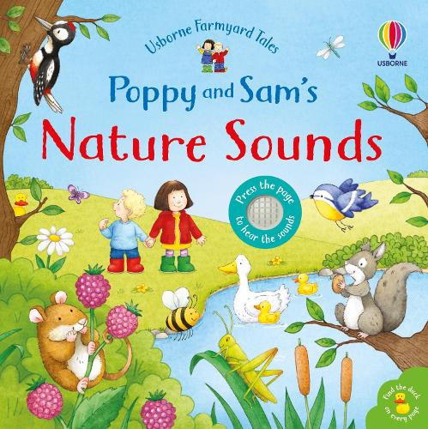  Poppy and Sams Nature Sounds by Sam Taplin | 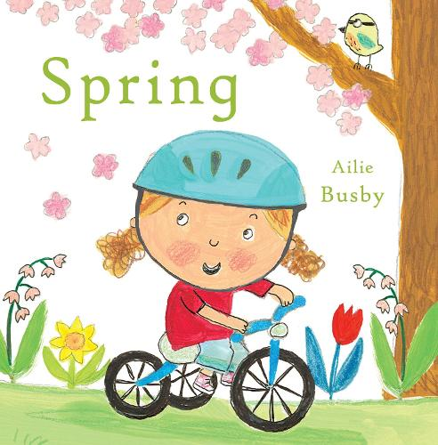  Spring by Ailee Busby | 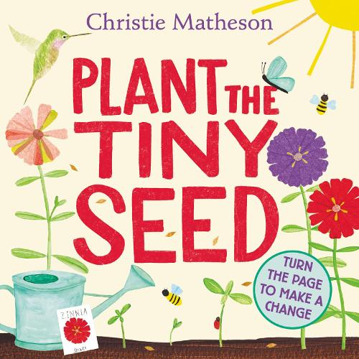  Plant the tiny seed by Christie Matheson
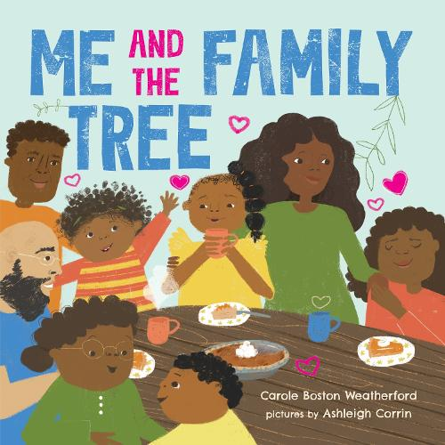  Me and the family tree by Carole Boston Weatherford | 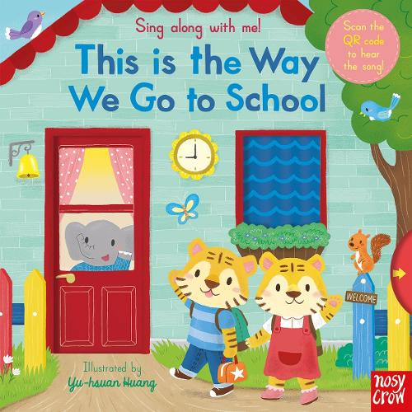  This is the way we go to school | 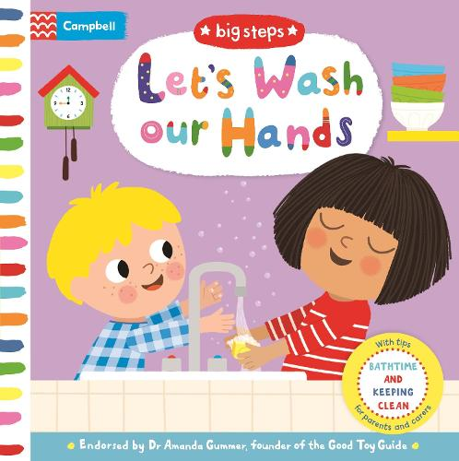  Lets Wash our hands | 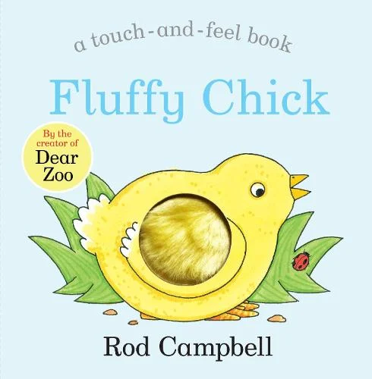  Fluffy Chick by Road Campbell
Alfred Sutton Reading Spine – ARP – Summer:
Year A Core Texts |  | Year B Core Texts
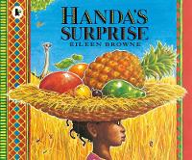  Handa’s Surprise by Eileen Browne | 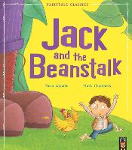  Jack and The Beanstalk by Mara Alperin and Mark Chambers | 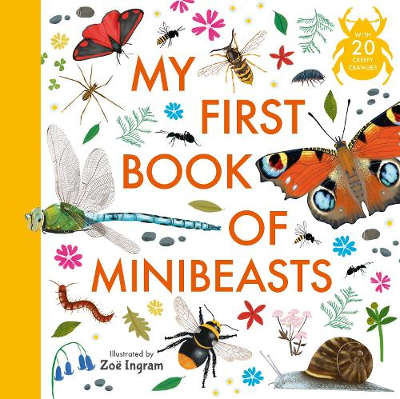  My First Book of Minibeasts by Zoe Ingram | 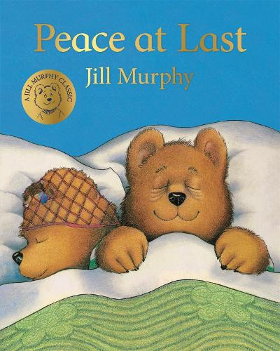  Peace at Last by Jill Murphy
Complimentary Texts Year A |  | Complimentary Texts Year B
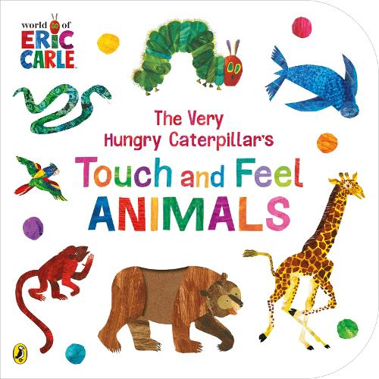  Touch and Feel Animals by Eric Carle | 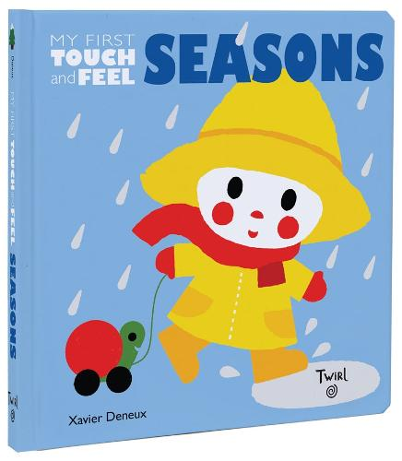  Seasons by Xavier Denuex | 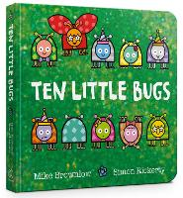  10 Little Bugs by Mark Brownlow | 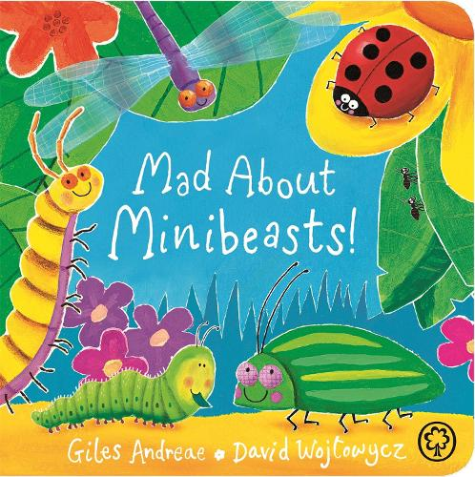  Mad about minibeasts by Giles Andreae
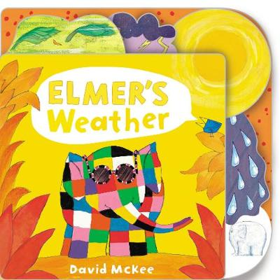  Elmers Weather by David McKee | 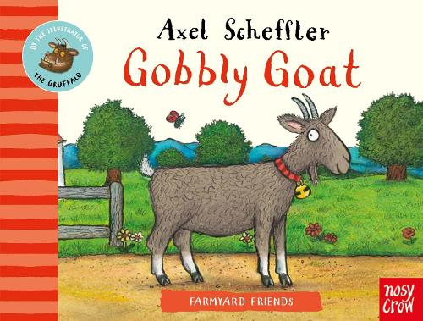  Gobbly Goat by Axel Scheffler | 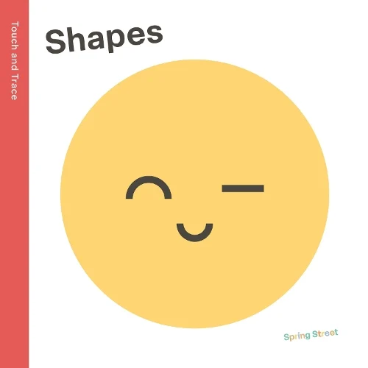  Shapes by Boxer Books | 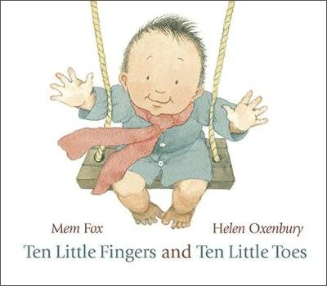  Ten Little fingers and Ten little Toes by Mem Fox

