Curriculum Policy

SUMMARY
This policy outlines the school’s aims, vision and ethos for a rich and broad curriculum

POLICY OWNER
Robert Howell
Headteacher

DELEGATION
Performance Enrichment Committee

DATE OF APPROVAL
11 January 2023

DATE OF NEXT REVIEW
11 January 2024

REVIEW CYCLE
Annual

PUBLISHED ON WEBSITE
Yes

_________________________

Paper copies available by emailing admin@alfredsutton.reading.sch.uk

Alfred Sutton Primary School
148 Wokingham Road
Reading
RG6 7BL
DFE No: 870/2000
www.alfredsutton.primary.co.uk

Contents

Foreword 3
Curriculum overarching aims 3
Ethos, vision and values 4
Ethos 4
Vision 4
Values 4
Sutton Six 4
British Values 5
Legislation and guidance 6
Roles and responsibilities 6
Intent methodology 7
Documentation 8
Implementation 8
Timetabling 9
Implementation pedagogy 9
Curriculum monitoring 10
Policy review 10
Appendix 1: intent documentation examples 11
Appendix 2: participation system 11
Appendix 3: examples of learning objective and steps to success 11
Appendix 3: helpful monitoring questions 12

Foreword
‘how students experience an activity is as much a part of what they learn as is the intended curriculum content’ (Nutall, 2007)
We believe that the following are key building blocks of a high-quality curriculum:
Curriculum intent – carefully planned content with clear end points that is ambitiously designed to maximise pupils’ cultural capital and skills
Curriculum implementation - well-taught lessons that break down content into appropriately sized steps to meet the needs of all learners
As curriculum intent and implementation are synergistic, these areas are both covered within the scope of the curriculum policy.

Links to other documents
Please reference this policy in the context of the following:
- EYFS policy
- Assessment policy
- SEN policy and SEN Local Offer
- Equality Policy

Curriculum overarching aims
‘A high-quality education, built around a rich curriculum, is a matter of social justice’ (Amanda Spielman, 2019)
- To provide a broad, spiral ‘big ideas’-based curriculum model to systematically build pupils cultural capital and essential subject skills
‘A student has to make sense of new experiences by relating them to already known concepts and evaluating them’ (Wilkinson and Anderson, 2007)
- To ensure pupils are well equipped for life in modern Britain through underpinning with the school ethos, vision and values
- To ensure accessibility and ambition for all so that strong progress is made from pupils’ varying starting points
- To educate the whole child by providing a well-rounded, engaging social, emotional and academic education
- To educate in a safe, nurturing environment where pupil welfare is central to all we do
- To champion and celebrate diversity by educating inclusively and respecting the rights of every child
- To educate creatively to pique children’s interests and passions
- To ensure pupils retain their learning as ‘sticky’ knowledge, enabling them to know more and remember more, which has a cascade effect of developing unconscious competence and fluency and building learning capacity

Ethos, vision and values
These form the bedrock of our curriculum and, as such, are included in this policy for easy reference.

Ethos
Happy together. Achieving together.
‘Intelligence plus character-that is the goal of true education,’ (Martin Luther King, Jr)

Vision
We are a school where:
- Children are encouraged to participate enthusiastically in high quality learning to achieve their full potential in every aspect of school life
- Children feel safe both physically and emotionally and are happy and confident to embrace challenges
- Children and staff work together in a mutually respectful, high quality learning environment.
- With high emphasis on spiritual, moral, social, ethical and physical development and where diversity is celebrated and respected
- Children’s skills and independence are nurtured to prepare them for their place in society
- Committed staff are keen to share their skills with the pupils and colleagues
- Parents feel welcomed and encouraged to participate in a working partnership
- A central role is taken in the community
- Children are keen to share their efforts and successes
- Children want to be

Values
Our curriculum is underpinned by our Sutton Six and British values.

Sutton Six
The Sutton Six are taught across every academic year in a cycle as follows so that they form the bedrock of an Alfred Sutton education:
Sutton Six Value | Focus term | In practice
Respect | Autumn 1 | Showing respect: from Nursery to Year 6, children are taught to treat themselves and others respectfully. Early Years and Key Stage 1 children learn that respect is treating everyone and everything well. In Key Stage 2, the children begin to learn that respect means caring about other people’s thoughts, feelings and emotions. The children also learn to respect our world and everything in it.
Resilience | Autumn 2 | Demonstrating resilience: from Nursery to Year 6, the children are taught that a resilient attitude can help them in all areas of their lives. Early Years and Key Stage 1 children learn that resilience is never giving up and to keep trying. In Key Stage 2, the children begin to learn that a resilient attitude is a ‘keep it up’ attitude, and that this can support them to learn from their mistakes and try new things
Aspiration | Spring 1 | Having aspiration: from Nursery to Year 6, children are taught to have goals to work towards. Early Years and Key Stage 1 children learn that aspiration is wishing to be or do something. In Key Stage 2, the children learn that aspiration is having a strong desire to work hard to achieve your dreams.
Responsibility | Spring 2 | Taking responsibility: from Nursery to Year 6, children are taught that responsibility is important for growth and independence. Early Years and Key Stage 1 children learn that responsibility is looking after people, belongings and your actions. In Key Stage 2, the children learn that responsibility is to do everything with care to show that you are reliable.
Caring | Summer 1 | Caring for the community: from Nursery to Year 6, children are taught that caring for the community shows we value the world around us. Early Years and Key Stage 1 children learn that caring for the community is taking care of Alfred Sutton. In Key Stage 2, children learn that caring for the community means to help and support people wherever they are.
Compassion | Summer 2 | Showing compassion: from Nursery to Year 6, children are taught that showing compassion ensures those around us are understood and respected. Early Years and Key Stage 1 children learn that showing compassion is taking care of others. In Key Stage 2, the children learn that compassion is to understand and care about people and appreciate their differences.

British Values
'British values mean that in Britain, no matter what your background, you can fit in, you can succeed, and you can belong.' (HM Chief Inspector, Amanda Spielman)

An Alfred Sutton education is underpinned by the British values in accordance with statutory expectations,
‘We want every school to promote the basic British values of democracy, the rule of law, individual liberty, and mutual respect and tolerance for those of different faiths and beliefs’ (DfE, 2014)
Our curriculum ensures pupils are equipped with the following knowledge and understanding:
- An understanding of how citizens can influence decision-making through the democratic process
- An understanding that the freedom to hold other faiths and beliefs is protected in law
- An acceptance that people having different faiths or beliefs to oneself (or having none) should be accepted and tolerated, and should not be the cause of prejudicial or discriminatory behaviour
- An understanding of the importance of identifying and combatting discrimination

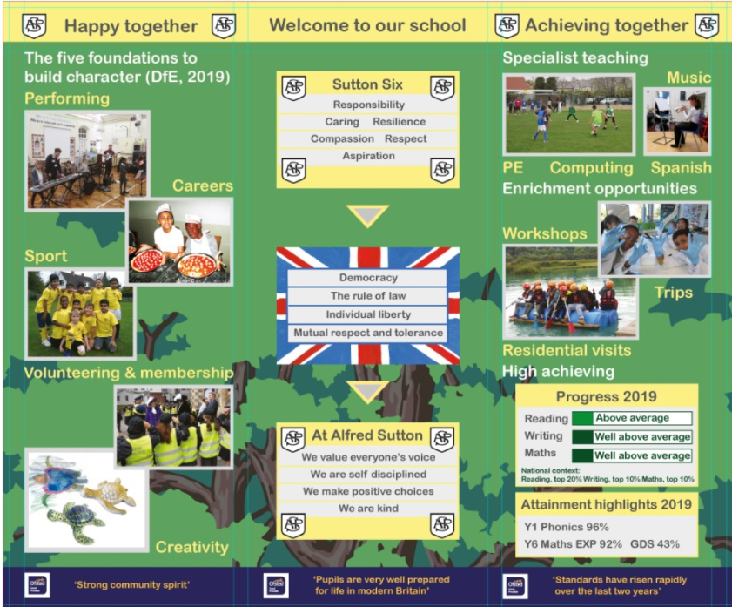

Legislation and guidance
- This policy reflects the requirements of the National Curriculum programmes of study, relationships and health education, personal development education and religious education
- It also reflects requirements for inclusion and equality as set out in the Special Educational Needs and Disability Code of Practice 2014 and Equality Act 2010, and refers to curriculum-related expectations of governing boards set out in the Department for Education’s Governance Handbook.
- In addition, this policy acknowledges the requirements for promoting the learning and development of children set out in the Early Years Foundation Stage (EYFS) statutory framework.

Roles and responsibilities
The governing board will monitor the effectiveness of this policy and hold the headteacher to account for its implementation.
The governing board will also ensure that:
- A robust framework is in place for setting curriculum priorities and aspirational targets
- Enough teaching time is provided for pupils to cover the National Curriculum and other statutory requirements
- Proper provision is made for pupils with different abilities and needs, including children with special educational needs (SEN)
- The school implements the relevant statutory assessment arrangements
- It participates actively in decision-making about the breadth and balance of the curriculum
- It fulfils its role in processes to disapply pupils from all or part of the National Curriculum, where appropriate, and in any subsequent appeals

Headteacher and senior staff, including inclusion, subject and phase leads work collaboratively with all staff in school, governors and other stakeholders, where appropriate, to ensure:
- All required elements of the curriculum, and those subjects which the school chooses to offer, have aims and objectives which reflect the aims of the school and indicate how the needs of individual pupils will be met
- The amount of time provided for teaching the required elements of the curriculum is adequate and is reviewed by the governing board
- Where appropriate, the individual needs of some pupils are met by permanent or temporary disapplication from all or part of the National Curriculum
- requests to withdraw children from curriculum subjects, where appropriate, are managed
- The school’s procedures for assessment meet all legal requirements
- The governing board is fully involved in decision-making processes that relate to the breadth and balance of the curriculum
- The governing board is advised on whole-school targets in order to make informed decisions
- Proper provision is in place for pupils with different abilities and needs, including children with SEND

Inclusion
We are ambitious for every pupil. Care is taken to ensure that our curriculum is highly inclusive for all pupils, including:

- Pupils with low, mid and high prior attainment
- Pupils with English as an additional language
- Pupils from disadvantaged backgrounds
- Pupils with SEND
Further information can be found in our statement of equality policy, and in our SEND policy and information report.

Intent methodology
Our curriculum subject intents are reflective of our aims.
Intent is broad, balanced, creative and inclusive. It is permeated by the Sutton Six and British values which also underpin our implementation model.
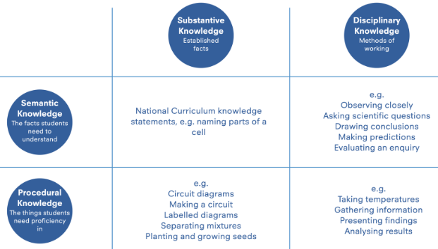
Subject intent is designed to maximise learning; it equips pupils with all three of the most commonly recognised categories of knowledge: procedural, semantic and episodic.
These are broken down with examples in this diagram (source: Chris Quigley Education Ltd, 2022)

‘At the very heart of education sits the vast accumulated wealth of human knowledge and what we choose to impart to the next generation: the curriculum.’ (Amanda Spielman)
Our subject intent champions our aims and is further meticulously designed with the following considerations factored:
- High quality children’s literature underpins with wider curriculum links where appropriate
- Logical sequencing of units
- Practice for concept mastery
- Key concepts (the ‘big ideas’) are identified to enable schema building
- Spiral knowledge and skills progression modelling
- Domain specific skills (e.g. analysis, evaluation, problem-solving, physical, artistic) are taught and applied helping pupils to develop their abilities, curiosity and learning thirst
- A well-reasoned rationale for selection of units where this is at the school’s discretion

Documentation
Our intent documentation is meticulously planned to ensure curriculum aims and subject design compliance.
Intent documentation is either school produced (using standardised templates for consistency) or externally produced where schemes are employed e.g. RWInc, White Rose maths, Oak Academy Spanish
Examples are provided in Appendix 1

Implementation
Promotion of consistency across implementation to embed a whole school culture in line with our intent: Happy together. Achieving together.

Timetabling

The following timetabling models are used:
Timetabling | Subject/s
Every lesson | English – spoken language  Personal development - school ethos, vision, Sutton Six and British values
Several times daily | Reading/phonics/vocabulary in context, writing (including SPaG)  ‘the greater one’s vocabulary, the easier one understands new content’ (Chris Quigley, 2022)
Daily | Maths  PE – active fit
Weekly | Personal development – RHE/PSHE  PE – NC units
Weekly (shorter lesson)/fortnightly (longer lesson) | RE, Design & technology, Art & design, music, computing, Spanish (KS2 only)
Blocks (10-15 daily lessons)  ‘Students need time to process new concepts; not simple repetition but opportunities to come at material in different ways’ (Nutall, 2007) | Science, history, geography; this model enables continuous, in-depth study for deep mastery of learning; associated cross- curricular writing further supports long term memory alterations building transferable ‘sticky knowledge’

Implementation pedagogy
We believe that the most successful implementation is underpinned by teaching, learning and ongoing assessment for learning pedagogy that promotes an inclusive, self-regulated, pro-social culture, and that this results in the strongest impact

Implementation | Implementation of intent: high quality and consistent positive pedagogy  - Pitch – high quality assessment for learning Appendix 1: assessment for learning in practice directs planning that maximises every pupils acquisition of knowledge and their ability to apply as skills  - Participation – all pupils participate fully in their learning Appendix 3: classroom pedagogy for promoting a pro-social, inclusive Teaching and Learning culture  - Praise – we praise positive learning behaviours to build social, emotional and intellectual IQ and all-round ability to self-regulate. Praise should always recognise and reinforce desired outcomes: ‘I like the way you tried different strategies on that maths problem until you finally solved it’  - Positivity – Fostering a love of learning amongst our pupils needs to be adult-modelled: staff’s enthusiasm and energy promotes pupil engagement.  - Purpose – what the children are to learn is made evident through a single clear learning objective. Measurable verbs introduce: e.g. name, explain, describe, label, use, calculate, plan, design, sketch, investigate. Steps to success signpost how the learning outcome is to be achieved (see Appendix 4: KS1 learning objective and steps to success, Appendix 5: KS2 learning objective and steps to success).  - Plenaries – timely plenaries (used throughout a lesson) maximise learning  - Precision – expert teacher knowledge and attention to detail– all policy and procedural expectations met  - Pupils’ work – high quality is expected and praised to promote pride; feedback on pupils’ work is used so that pupils understand how they are doing / how to further improve to master before moving on  - Progress - high expectations permeate – aspirational classroom culture
Impact | Our impact:  Pupils are well equipped emotionally, socially and academically to fully access their next stage of education  Impact aims:  - Emotionally – pupils are confident, positive participants who fully access life’s opportunities  - Socially – pupils have self-respect and respect for each other; they include and feel included themselves  - Academically – pupils have the knowledge and cultural capital to equip them for success

Curriculum monitoring
Monitoring methods include the following:
- Pupil voice
- Pupil work
- Subject leader in depth enquiries
- Internal and external moderation by teachers, leaders, Governing Board, LA and OFSTED

Policy review
The policy will be reviewed annually, or sooner if necessary.

Appendix 1: intent documentation examples

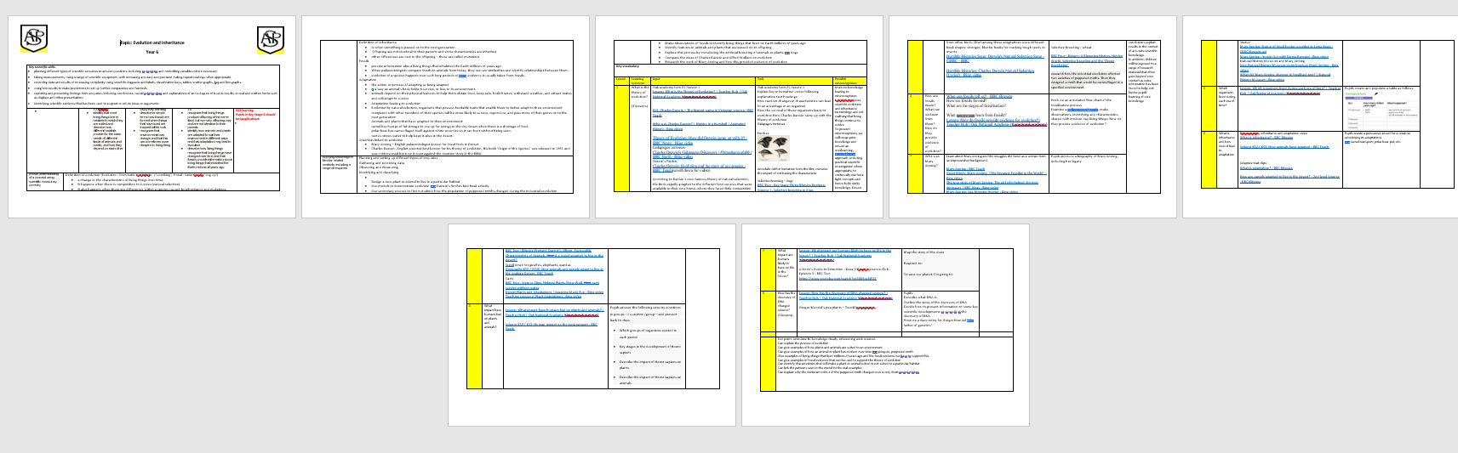

Appendix 2: participation system
Every pupil should be given chance to access every question (no initial hands up, thumbs up or lolly sticks). School wide strategies and signals underpin for consistency:
- Stop signal
- Choral response (palm out to class)
- My turn (gesture towards yourself with one or two hands)
- Your turn (gesture towards the children with one or two open palms)
- Turn to and discuss with partners (hands as gates open to gesture talk partners, closing when time to discuss)
- Handwriting signal (hold up a pencil in one hand with other hand flat)
- Paraphrasing (some of the children’s responses – ‘I heard . . .’)
- Popcorn (children call out their answers one at a time)
- Word wave (children call out in line with teacher sweeping hand across the group)
- Signal for Concluding input: routine use of explaining task expectations to partner and then back to teacher; agree timed work output targets to enable all pupils to develop time-management, numerical quantity – show on whiteboard/on fingers, as appropriate.

Appendix 3: examples of learning objective and steps to success

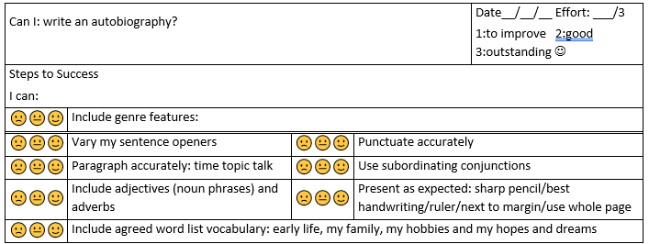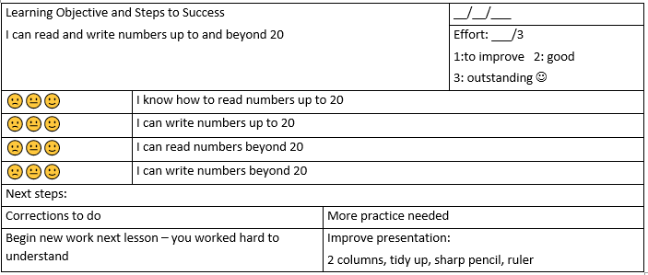

Appendix 3: helpful monitoring questions
Children
- I see you were learning about x what do you know already- what’s new
- Can you tell me about (use the previous year's NCTEM progression criteria to check retained knowledge)
- What sort of problems have you been involved in solving in this area- show me in your book. Can you tell me what this problem asked you to do? What knowledge or method did you use? How did you know/check if your answer was correct
- did your teacher teach you how to work this way or did you learn through doing it
- Do you feel successful in all areas of Maths? Which bits are tricky?
- Do you do quizzes or test yourself?
- Do pupils see a value in maths, both personally and in wider society and employment?
Teachers
- What do you want children to know and be able to do independently at the end of this sequence? What component knowledge needs to be taught and secured for them to achieve these endpoints?
- Today I saw you teaching x- what knowledge are you building on -What components are coming next?
- How are you using modelling and guided practice to secure fluency?
- What misconceptions could children have- how do you teach this?
- What do you do to support SEND? (looking for short, high frequency, additional guided practise and security in declarative knowledge)
- How do you check for understanding before moving on to the next component?
- How will you know if children have learned this at the end of this unit – how will this help you identify any misconceptions or missing knowledge components
- Tell me how you teach so that children remember key knowledge long term?
- How do you ensure children reach automaticity in recall of key maths facts by the end of the year?
- How are you supported to develop subject and subject-specific pedagogical knowledge?
- How helpful are curriculum materials provided to support your teaching?
- Are adequate resources available?
Leaders
- How do you make choices about what knowledge gets taught and in what order ( sequencing)- from EYFS

- How do you ensure that what children know already supports subsequent learning (within lesson sequences for each year group)-?

- How do teachers in your department know what knowledge must be taught and when- how is this communicated?

- Ho do teachers plan units of work- how do they identify the components that build up to endpoint performance

- How do you expect teachers to plan so that knowledge transfers from the teacher to the pupil's long-term memory?

- How do pupils gain declarative knowledge, method knowledge, strategy knowledge?

- How do teachers check which knowledge components are missing/not automatic and what are the typical gaps in pupils’ knowledge and skills by Yr 2/6/11? How has the curriculum sequence been planned in KSX to address these typical misconceptions/ knowledge or skill gaps?

- How are manipulatives and other scaffolds used- when are they taken away- how do you teach vocab/ manipulatives/ calculation methods so that cognitive load is minimised

- How do you ensure task design is appropriate (keeps the child thinking about the components they are learning/provides opportunities for pupils to show depth in knowledge and proficiency in performance at endpoints?

- What choices have you made about curriculum following COVID lockdown and why?

- Will we see your intended curriculum consistently implemented across year groups? what have you learned from subject monitoring – what strengths and development areas have you identified and what is the impact of any actions?

- How do you know that children learn the curriculum- how do you check?

- What do you expect teachers to do to help knowledge stick in pupil memory? How consistently is this applied and what is the impact?

- How are pupils falling behind or opting out identified - what is put in place and how impactful has this been in keeping children on track and enthusing them?

- Does whole-school timetabling, marking, assessment and CPD policies and priorities affect improvement within your subject?

