Alfred Sutton Handwriting

Good handwriting is an essential skill and must be taught by demonstration, explanation and practice across the whole school.
Teacher modelling is vitally important to ensure that children are shown how to write neatly, fluently and accurately. All of our handwriting sessions include elements of teacher modelling. Throughout the school day, teachers and LSAs will consistently use and model writing following our agreed handwriting style.
At Alfred Sutton, we believe that handwriting is a developmental process with its own stages of progression from letter formation through to letter joins. It is important that children are taught letter formation in the correct families before they move onto joining their letters. We ensure that children have correct letter formation, letter direction and spacing are all embedded and used with skill before introducing joined up handwriting

This handwriting policy is intended to enable all children in the school to develop a flexible, fluent and legible handwriting style, which will enable the children to write with confidence and creativity.

Foundation Stage
In Foundation Stage we build strong foundations to ensure that the children are able to write neatly and fluently. Our classrooms are set up with numerous daily opportunities for children to practise the fine and gross motor skills that are required for handwriting. Opportunities for early mark making are frequently explored through the school day and teachers encourage and model different ways to do this.
When children begin to use a more formal style of writing, teachers and EYPs model accurate sitting to ensure children are comfortable and able to write as fluently as possible. Children are shown how to hold a range of writing implements in the palmer grip when making marks.
From the beginning of the reception year, children are taught correct letter formation during their daily Read Write Inc. lessons. They are shown how to write each letter and are taught catchy phrases and rhymes to support them with remembering correct letter formation. Children practice handwriting every day and adults support with accurate letter formation. Children are encouraged to hold the pencil using a palmer grip when writing and to write following the direction of letters taught through teacher input.

KS1
In Key Stage One children follow the Nelson handwriting scheme. Our key focus is on accurate letter formation and sizing. We focus on the terms ascender and descender ensuring that children are confident to form all letters accurately and with speed and fluency. Finger spaces are also reinforced in all writing sessions to ensure that handwriting is as clear and accurate as can be. Handwriting takes place on a daily basis and always involves teacher modelling, guidance and support.

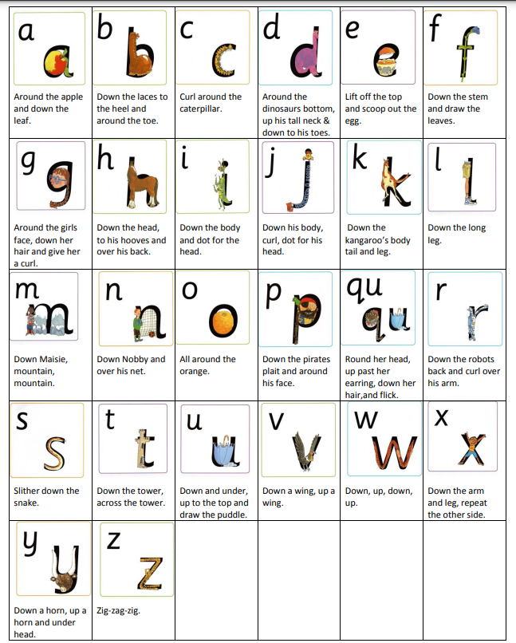

Note- Children in year 2 who have mastered individual letter formation will be given targeted support in accurately joining their writing. They will follow the joins agreed by staff in the school for KS2. They will follow the Nelson Handwriting Scheme to develop a structured and logical order to their joined writing development.
In KS2
The majority of children will be introduced to joins at the very start of KS2. Targeted interventions will take place for those who still need guidance with accurate letter formation. KS2 children will follow the joins below ( as discussed and agreed as a staff). Staff will also model this handwriting in all of their marking and writing on the board. KS2 children follow the Nelson Handwriting Programme. This programme allows for joins to be introduced in a logical order building on prior learning. Handwriting takes place on a daily basis and always involves teacher modelling. There are ample opportunities for children to practise new joins and letter formation.

KS2 Handwriting joins
